Bash Script Tasks
1 Create a bash script to check if a directory is available or not.
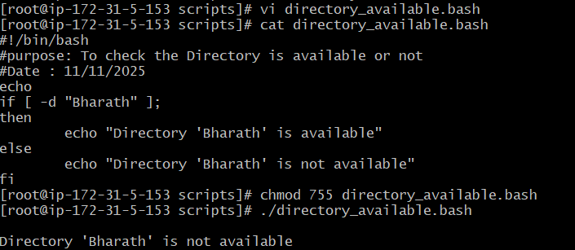
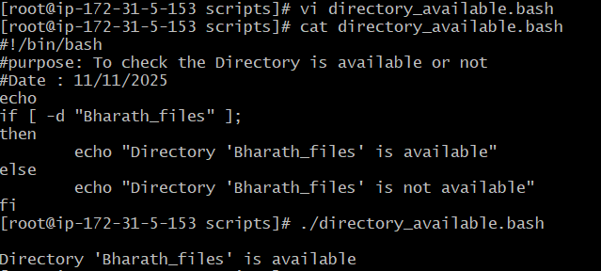

2 Create a bash script to create multiple files.
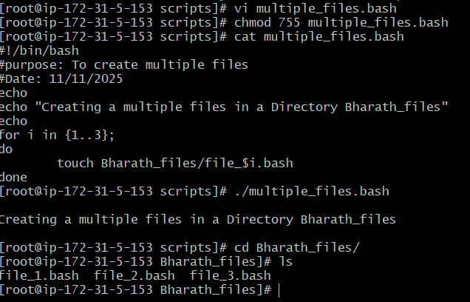

3 Create a bash script to take a backup of a directory
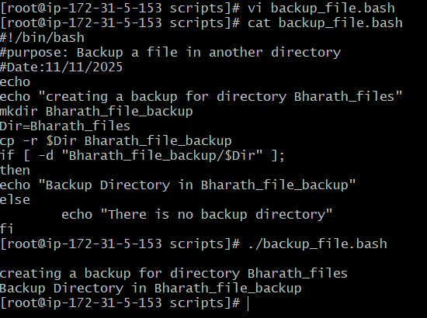
4 Create a bash script to install Nginx on an EC2 server.

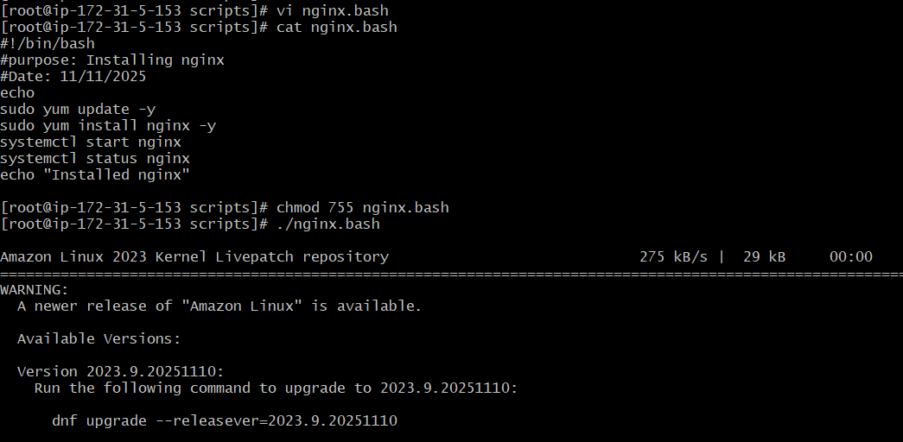
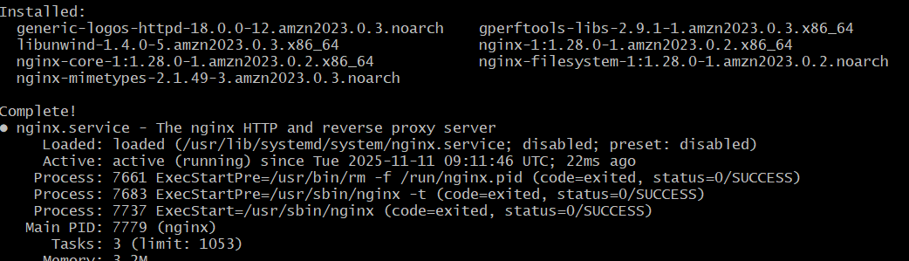

- Create a bash script to install Apache Tomcat on an EC2 server.
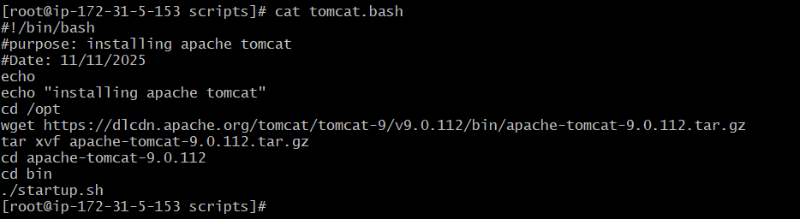
–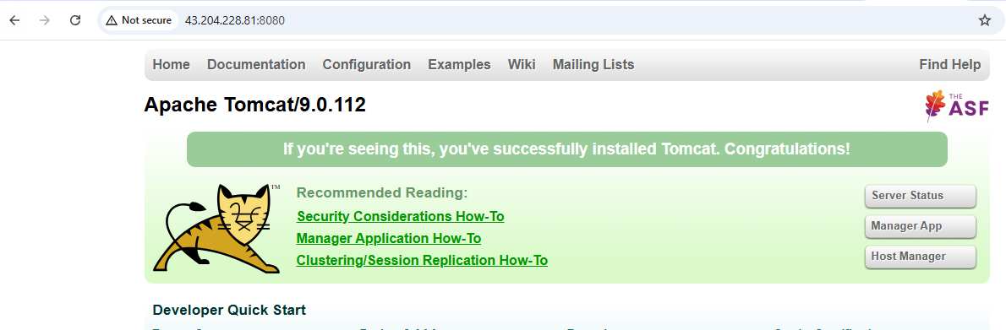

6 Create a bash script to check if the Nginx service is running, if not running then script should start the service.
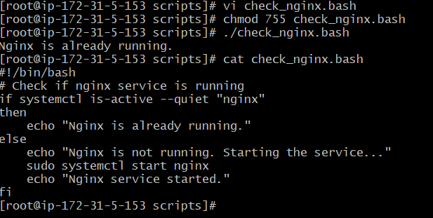

7 Create a bash script for a calculator.
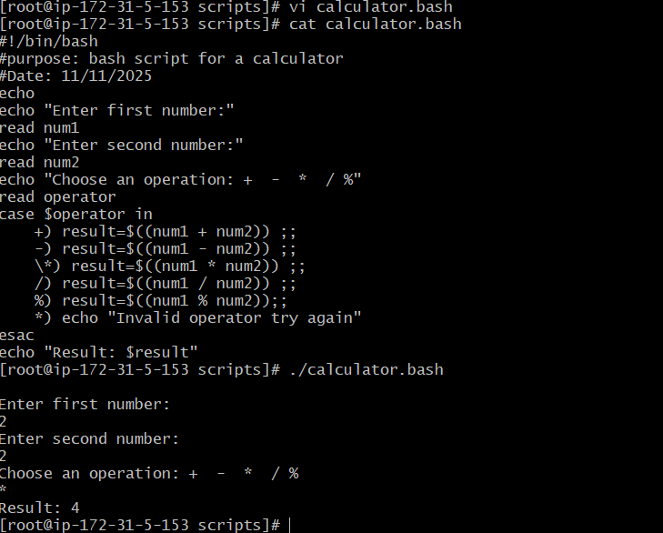

- Create a bash script to check if a directory exists, if not then create a directory.
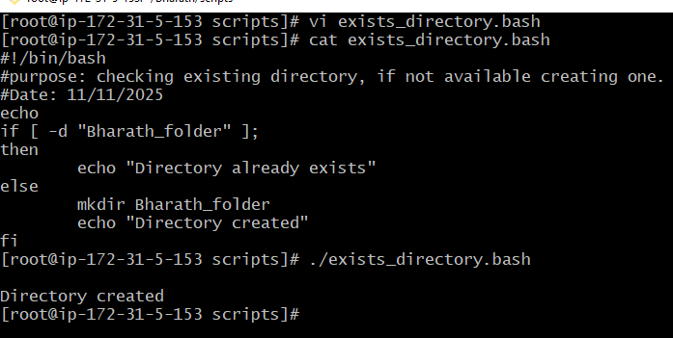
- Create a bash script to delete the last 3 lines of a file

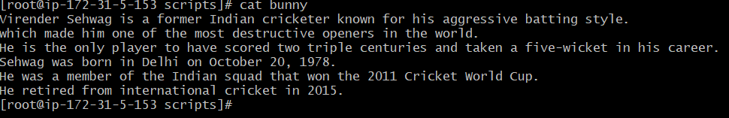

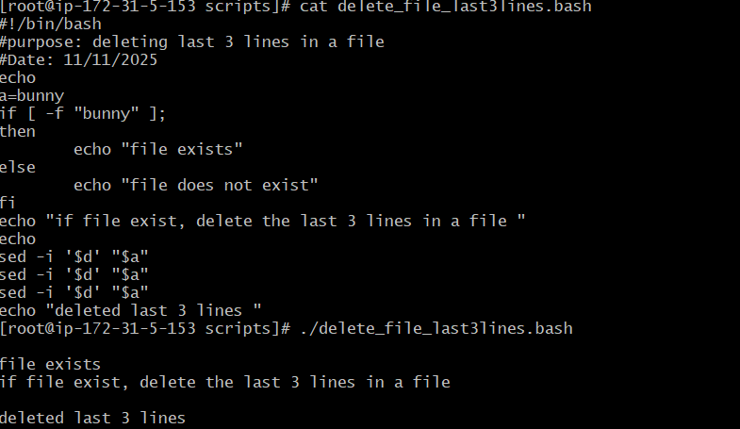
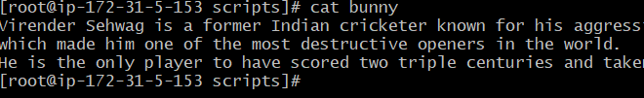
.
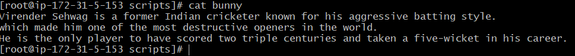

- Bash script to monitor cpu and if it is more than 80% then send email notification

yum install mailx

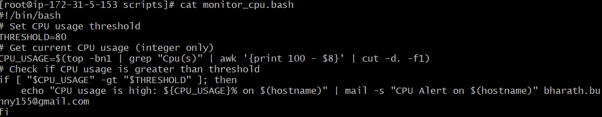
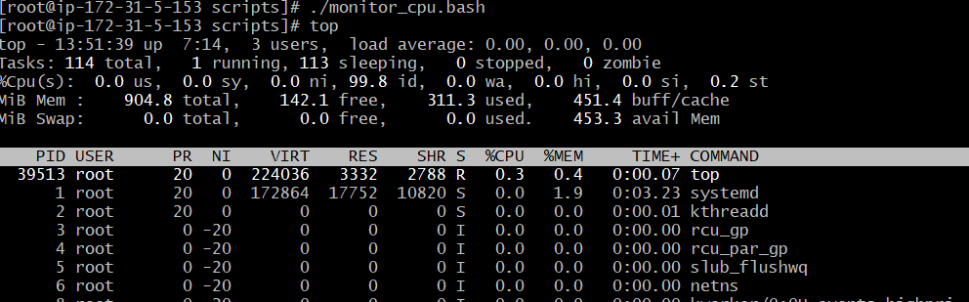

- Bash script to monitor disk space and if it is more than 80% then send email notification.
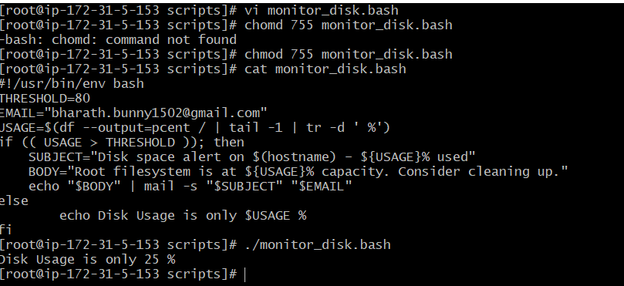

- Bash script to monitor memory and if it is more than 80% then send email notification.
